University Of Engineering and Technology, Lahore
Computer Engineering Department

Course Name: Programming Fundamentals | Course Code: CMPE-112L
Assignment Type: Lab tasks | Dated: 1 June 2026
Semester: First | Session: 2026 Spring
Lab/Project/Assignment #: 1 | CLOs to be covered: CLO 2
Lab Title: OS Library, if __name__ == "__main__", is vs == | Teacher Name: Hafiz Muhammad Mubashar
Lab Evaluation:

CLO2 | Apply appropriate programming techniques to create executable programs to solve well defined problems
CLO2 | Level1 | Level2 | Level3 | Level4 | Level5 | Level6
(5)
Total |  |  |  |  |  | /5
Rubrics for Current Lab Evaluation
Scale | Marks | Level | Rubric
Excellent | 5 | L1 | Submitted all lab tasks, BONUS task, have good understanding.
Very Good | 4 | L2 | Submitted the lab tasks but have good understanding
Good | 3 | L3 | Submitted the lab tasks but have weak understanding.
Basic | 2 | L4 | Submitted the lab tasks but have no understanding.
Barely Acceptable | 1 | L5 | Submitted only one lab task.
Not Acceptable | 0 | L6 | Did not attempt
Week 2 LAB
OS Library, if __name__ == "__main__", is vs ==
Lab Goals/Objectives:
• To understand the concept of modular programming by splitting code into separate Python files.
• To learn how to reference and execute code from external files using the import statement.
• To master the purpose of the special __name__ == "__main__" conditional check.
Equipment Required:

* Computer/Laptop
* Python 3.14
* VS Code or pycharm

Theory:
As programs grow larger, keeping all code in a single file becomes unmanageable. Python allows you to break scripts down into separate reusable files called modules.
Lab Work:

Task 1: Defining a Reusable Module Function
def welcome():
print("hello world")
if __name__=="__main__":
welcome()
print(welcome())
Result:

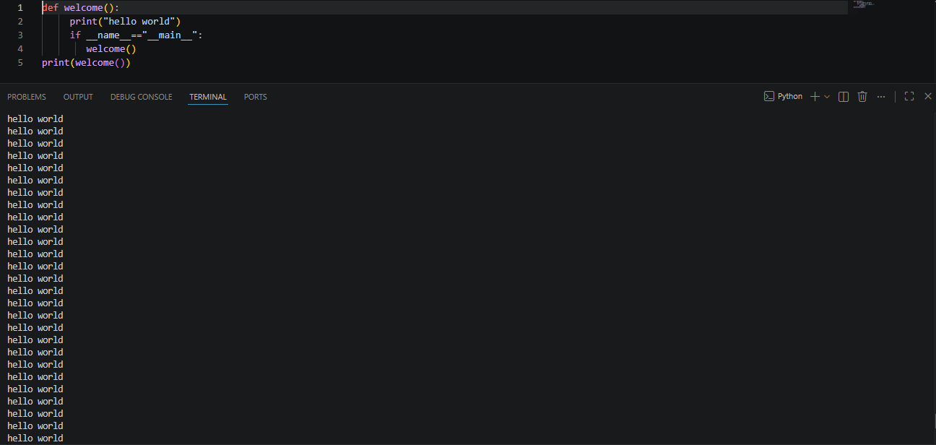

Task 2: Importing and Invoking External Module Logic
import task_7
task_7.welcome()
Result:

Conclusions:
This lab successfully demonstrates the fundamentals of code serialization and modularity in Python. We explored how to build independent code assets in a module file and call them from an external script. Furthermore, we analyzed how the __name__ variable acts as an execution guard to separate immediate standalone test scripts from safe, importable function collections.

